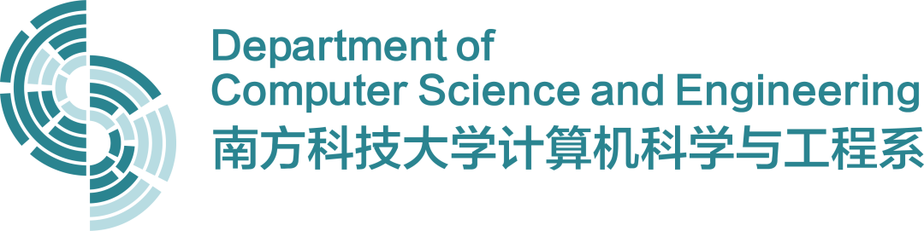

|  |  |  |
| --- | --- | --- |
| **2022-2023 Spring Semester** | | |
| **Group Projects** | | |
| **Project Declaration Form** | | |
| List of team students | | |
|  | Student ID | Student Name |
| 1 | 12011517 | 李子南 |
| 2 | 12010205 | 高云舒 |
| 3 | 12011715 | 张霄天 |
| Project Title | 基于无源域自适应的医学图像增强 | |
| Supervisor Name | 刘江 | |
| Abstract (Project Objectives):  Unsupervised domain adaptation (UDA) via deep learning has attracted appealing attention for tackling domain-shift problems caused by distribution discrepancy across different domains. Existing UDA approaches highly depend on the accessibility of source domain data, which is usually limited in practical scenarios due to privacy protection, data storage and transmission cost, and computation burden.  To address this challenge, we propose to develop a source-free unsupervised domain adaptation method for enhancing medical images. Our method will leverage only the training parameters of the source model to achieve effective and robust UDA. This will significantly enhance the generalizability and transferability of medical image enhancement algorithms across diverse imaging domains, while also reducing the burden of acquiring large-scale annotated data for training. | | |
| **Team students:**  (Signature) | | |
| **Supervisor:**  (Signature) | | |